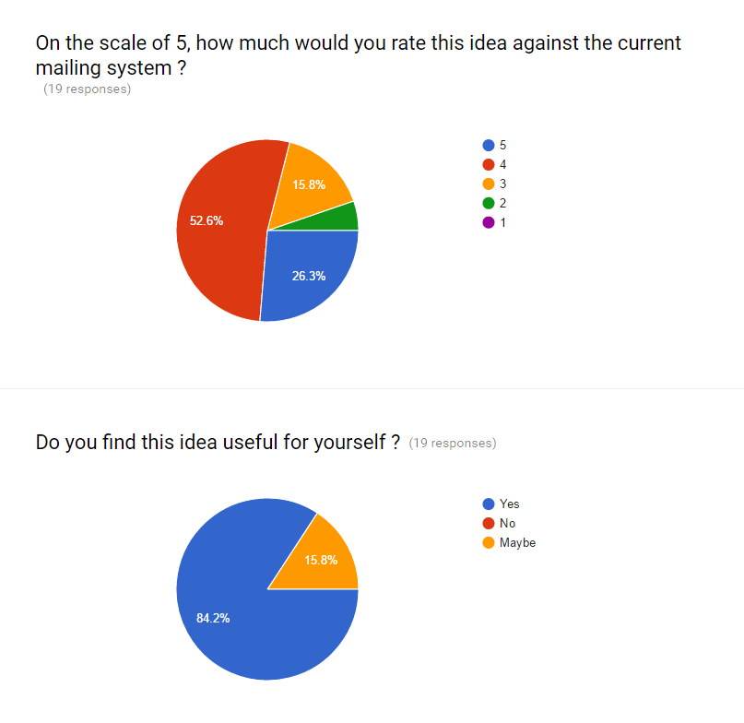

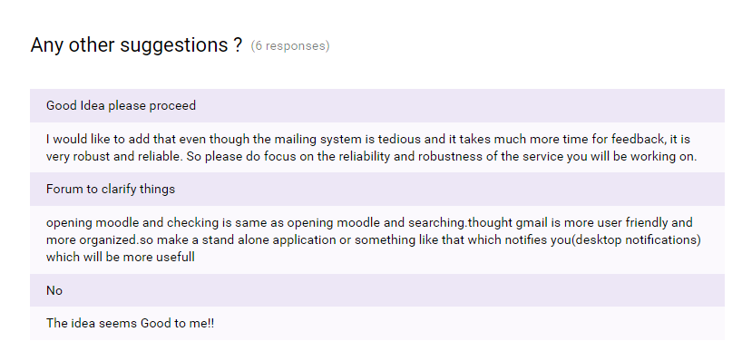

Feasibility Analysis Report:

1. The pie charts above suggest that this idea is capable of coping up with the current situation of this university.
2. 84.2% of people think that the current mailing system is not that feasible and having a simple portal is good to handle those situations.
3. People have also given us suggestions which we have already added in our software.
4. If this system wasn’t implemented then the reliability would be degraded for example, sometimes in the mail there is useful information but also most of the times they are spam e-mails which is going to be completely removed after this software implementation.
5. The current problem is mainly the waiting part, where a student who needs to deliver an information has to first send an e-mail to the dean academics and after his approval only the mail is generated to every student which is not that efficient.
6. This system after the Implementation will remove the above mentioned issue as the student does not have to wait for anyone’s approval. He/she just has to publish a valid post and everybody will be notified about the post and they can respond accordingly.
7. Our software will provide the facility for users to notify every person in this college about any possible thing which includes lost and found of something, making of groups, event notifications, festival celebration etc.
8. According to the facilities that the software would be providing, we will be working on apache server and the website will be built using HTML , PHP and Visual Studio.